Insect Identification

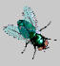 Blow Fly
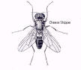 Cheese Skipper
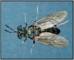 Soldier Fly

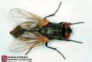 House Fly

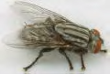 Flesh Fly

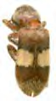 Clerid Beetle
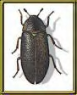 Hide Beetle

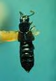 Rove Beetle

